## Convolutional NN

### Computer Vision Use cases Examples

Image classification -> Say if an image belongs to a specific class or not.

Object detection -> Identify the objects present in an image and give their position through bboxes.

Neural Style Transfer -> Having a content image and a style image, redraw the content image using the style of the other picture.

### The problem of the images sizes

Images are high dimensional inputs, leading to big numbers of features.

And with that many parameters, it's difficult to get enough data to prevent a neural network from overfitting. Also, the computational requirements and the memory requirements to train a neural network with many parameters is just infeasible.

### Convolution operation

It consists in convolving a kernel or filter through all the image, getting a smaller version of the image, where each element is the result of the convolution of the filter with the corresponding part of the image.

By doing so, and depending on the value of the elements of the kernel, you get an output that somehow represents a feature discriminated by your filter.

So, convolution NN are NN that try to automatically the best fitting values for each of the kernels.

### Padding

It consists in adding new columns and rows to the borders of the images. This prevents two downsides of convolutions:

1. When applying convolutions, the images get smaller each time. After many layers, this can become troublesome, as your output image can get too small, losing information.
2. The values of the pixels in the borders of the input images have less weight in the output image than the values of the pixels in the middle zones. So we are throwing away a lot of the information near the edges of the images.

**How much to pad: Valid vs Same convolutions?**

Valid:No padding

Same: Pad so that the output size is the same as the input size.

$$Output_{size}= input_size+2*padding – filter_size + 1$$

Nota: The filter size is usually odd, so you get a natural/symmetric padding region and also because this way you always have a central pixel in the filter. But its mainly for convention.

### Strided convolutions

The stride is how many pixels you move/make your filter jump through the image in each convolution step.

$$Output_size \frac{= input_size+2*padding – filter_size }{stride}+ 1$$

Nota: If this fraction is not an integer, we round it down to the nearest integer. This is done so if the filter gets out of the image, the operation is not computed. Its just a convention. It’s interesting to note that the python type broadcasting int always rounds towards 0 (=floor is int >0, =ceil if int < 0).

### Convolutions over volume

Colour images are usually represented in the RGB convention, so you end up with matrices of height x width x 3 sizes. This can be seen as three times the same image but in the red, green and blue colours. Therefore, you take a f_size x f_size x 3 and perform each filter_size x filter_size convolution over each one of the three images, adding them up.

### Convolutional NN

**CNN layer**

In order to create a CNN layer, what you do is you take the output image of your convolution, add a bias to all the elements of this output and the apply a non-linear activations, obtaining a new output image of the same size but with a NN structure.

The number of parameters of a convolution layer is given by the following formula:

$$N_param = (filter_h x filter_w x n_channels_l-1 + 1) x n_channels_l$$

**Pooling layer**

Pooling layers reduce the size of the representation, speed the computation, as well as make some of the features that detects a bit more robust.

It works by dividing the input image in regions and calculating the average or max of the pixels in each region. The hyperparameters that define the pooling operation are the size of the regions and the stride. The output will have the following size (padding is usually omitted = 0):

$$Output_size \frac{= input_size+2*padding – filter_size }{stride}+ 1$$

As opposite to the CNN layer, the pooling is performed in each channel independently, so the final size in the third dimension is kept.

You usually use max pooling over average pooling, except for the case where you are very deep in a NN and you want to collapse your representacion from h x w x c to 1 x 1 x c.

Note: Don’t try to reinvent the wheel! Look into the literature for architectures that are known to work well.

Note 2: Usually, the size of your activations drops down as we go deeper in the neural network, but if it drops too quickly that’s not great for the performance

**Why convolutions?**

They present parameter sharing and sparsity of connections.

**Parameter sharing:** A feature detector that’s useful in one part of the image is probably useful in another part of the image. They are good at capturing translation invariance.

**Sparsity of connections:** In each layer, each output value depends only on a small number of inputs, as opposite to the case of the fully connected layers.

## Deep Convolutional Models

In computer vision, it is quite common to use transfer learning in order to adapt models trained for other tasks to your own task, as they usually work quite well.

Some of the **classic** and most used models are **LeNet-5**, **AlexNet** and **VGG**. More **modern** architectures are **ResNets** and **Inception**. Some **light** CNN popular models are the **MobileNet** and the **EfficientNet**.

Some of the common patterns you see in these **classical architectures** and that era usually still seen nowadays are:

* As you go deeper into the net, the image size diminishes and the number of filters augment.
* Pool layers are often placed between conv layers.
* The final features obtained by the conv net are fed into a series of fully connected layers in order to get the desired output.

### ResNets

They allow to train really deep NN by skipping connections, taking early activations and feeding them to another layer much deeper in the NN.

**Residual blocks**

They work by **adding an early activation** later in the NN, **right before applying the activation function** of the later layer. This helps reduce the problem of vanishing/exploding gradients.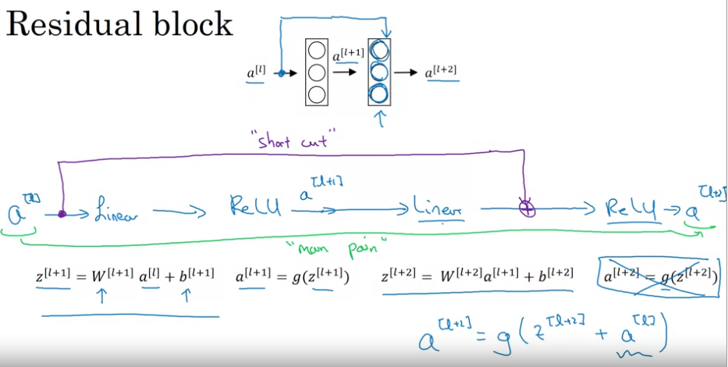

**Why ResNets work?**

They allow the model to really skip connections if they are not useful, making z[l+2] + a[l] approximately equal to a[l]. Note that for adding up this two elements, they need to have the same dimensions. This is easily done in conv nets by using the “same” padding through your “skipped” layers, so all outputs have the same dimension, or you can directly pad a[l] when summing it or just multiply it by a set of learnable parameters.

### Inception Network

#### 1x1 convolutions

They can be seen as applying a fully connected operation to each one of the pixels and through the different channels of an input volume.

If you choose a lower number of filters, it can help you shrink the number of channels of your output volume. You can also augment the dimension with a greater number of filters.

If you choose the same number of filters, it adds non-linearity, allowing you to learn a more complex function of your network.

#### Motivation

Instead of choosing what type of layer to use, the idea behind inception is to use all the layers and stack the different outputs in different channels. But because this implies a huge computational cost, they implement the “bottleneck” layers: intermediate layers that reduce the number of channels so the operation is “cheaper”.

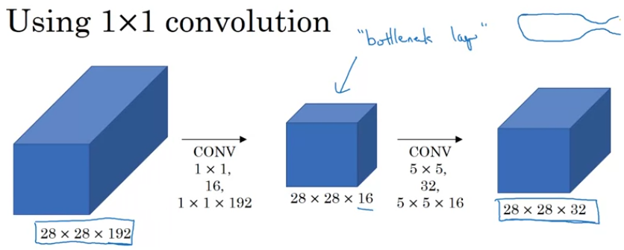

Nota: If done within reason, the fact of reducing the dimensionality doesn’t reduce the performance, but reduces the computational cost. Incredible, isn’t it?

#### How to build an Inception Network

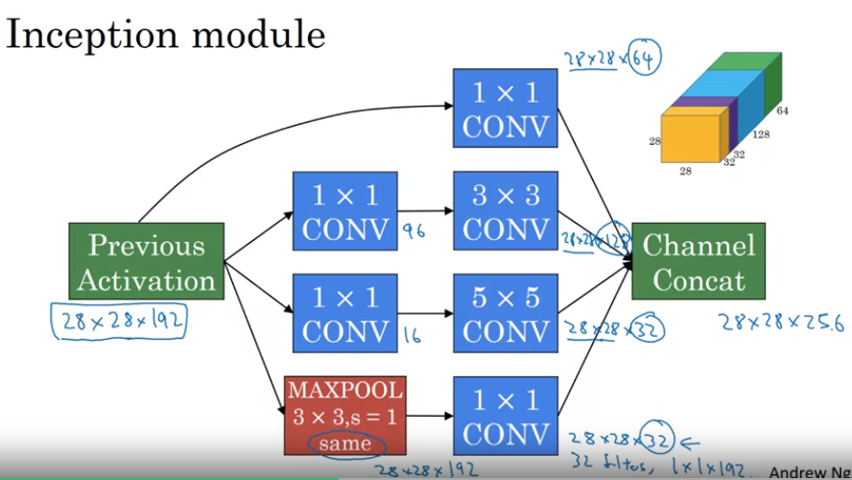

The inception network basically consists in a lot of inception blocks put together, with some intermediate max pooling layers to reduce dimensionality.

Another interesting incorporation to the inception network is the multihead, which outputs a softmax distribution at different depths of the network. It has sort of a regularization effect.

### MobileNet

The main idea behind the MobileNet was to develop a low computational cost net. For doing so, it implements a depthwise separable convolution.

#### Depthwise Separable Convolution

You perform a depthwise convolution followed by a pointwise convolution.

A depthwise convolution is one that applies each filter to only one of the respective channels of the input volume.

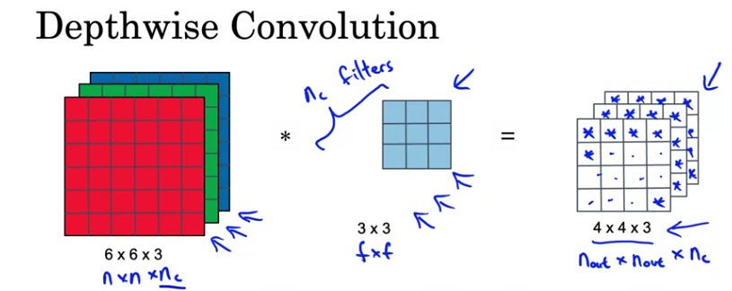

Later, in the pointwise convolution, you take the output volume of the depthwise convolution, which keeps the number of channels of the initial volume, and apply a normal 1x1 convolution to all, i.e., through all the cannels. This way, you can change the final number of channels depending on how many 1x1 filters you apply.

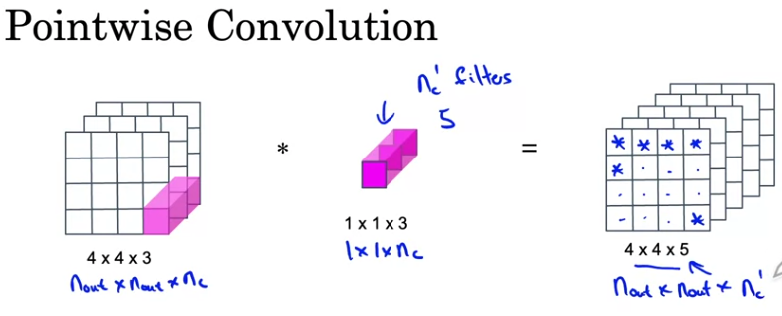

The computational cost reduction can be calculated as:

$$Cost reduction=\frac{1}{num_channels}+ \frac{1}{{f_size}^{2}}$$

#### MobileNet Architecture

Apart from the depthwise separable convolution, MobileNet v2 incorpored residual connections and an expansion operation prior to the depthwise operation.

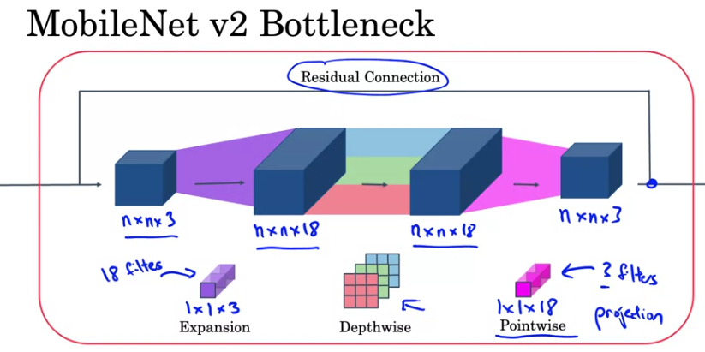

The expansion step allows the net to learn a more complex representation, by augmenting the size of such representation. The pointwise/projection step gets the size back down, so it helps save memory, which is a key factor when deploying in lower powerful devices.

### EfficientNet

It helps take you a baseline model and tune it to your application, scaling it up or down.

So, if you want to scale a model you usually can play with the image resolution, the depth of the net or the width of the layers.

The question remains what values for the resolution, depth of the NN or width of the layers you need for a given set of computational resources. The open architectures of EfficientNet available help you with this problem.

## Practical advice on using CNN

### Using open-source implementations

Even by reading a paper, it is difficult to exactly replicate the work, due to the great number of choices the programmer has to make. Therefore, if you want to take a work as your departing point, it’s advisable to look into GitHub for open-source implementations. It will help you save a lot of time and headaches!

### Transfer learning

It works by getting the trained weights of a particular architecture and retrain only the last layers so you can fine-tune the model to your application.

You can think of this as getting your input images, obtaining a set of features and feeding them to your shallow model. In fact, one way to save time is to pre-compute this features, save them and then feed them to your shallow model during training.

You can unfreeze more layers if you have a lot of data; unfreeze less layers if you have few data.

### Transfer learning important notes

**What you should remember:**

* When calling image_data_set_from_directory(), specify the train/val subsets and match the seeds to prevent overlap
* Use prefetch() to prevent memory bottlenecks when reading from disk
* Give your model more to learn from with simple data augmentations like rotation and flipping.
* When using a pretrained model, it's best to reuse the weights it was trained on
* When you use a smaller learning rate, you take smaller steps to adapt it a little more closely to the new data
* For transfer learning, the low-level features can be kept the same, as they have common features for most images. When you add new data, you generally want the high-level features to adapt to it, which is rather like letting the network learn to detect features more related to your data
* When freezing layers, avoid keeping track of statistics (like in the batch normalization layer)

### Data augmentation

It is a technique based on the presumption than in computer vision specially, you can always make use of more data.

**Common data augmentation methods**

* Mirroring
* Random Cropping -> Isn’t perfect, as it can add noise (like taking the background of your image as if it was the object you are trying to classify). But if its randomly distributed and has enough subsets from the original image, it should work well.
* More complicated distortion like rotation**,** shearing distortion, local warping, etc.
* Color shifting -> It makes your algorithm more robust to changes in color. PCA color augmentation is an interesting approach for this.

### State of Computer Vision

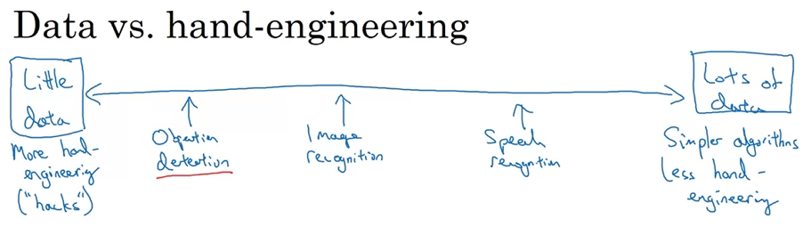

An AI algorithm has to sources of knowledge: the labelled data and the programmers knowledge: hand engineered features, network architectures, etc.

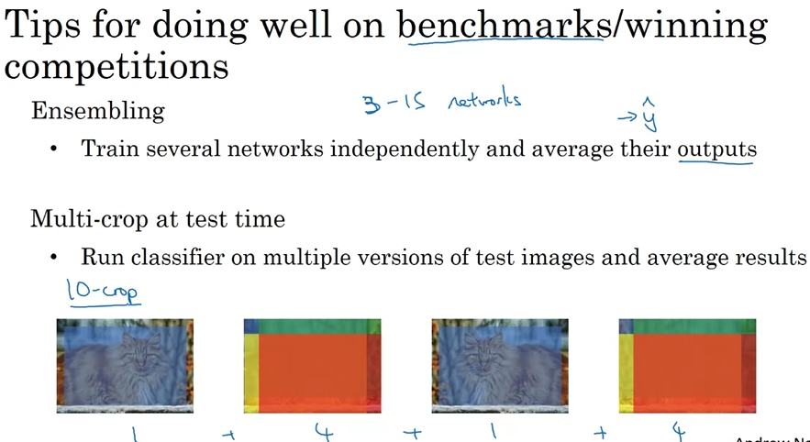

These techniques are usually not useful when deploying systems, as they augment the computational cost significantly.

## Object detection

### Object localization

Object localization is the process of not only classifying an image among different labels, but also putting a bounding box around the position of the object in the image.

For training this kind of network, you basically just take a classification net with a softmax layer with n classes and add 4 more outputs: bx, by, bh and bw. You will also need to have the labels for these four values.

Nota: bx and by correspond to the coordinates of the center of the rectangle (usual convention, with the upper left corner as the 0,0), while bh and bw correspond to the height and width of the bbox.

In practice, your label vector will also include an extra value, which is 1 if there is any object in the image, or 0 if there isn’t. In the later case, no bbox or classifications need to be performed.

### Landmark detection

It consists in detecting a series of landmarks or key points in your image. For doing so, you train your CNN with an output layer that has twice as many units as key points you want to detect, for the x and y coordinates. Obviously, your labels should also have these points marked.

In practice, you have an extra unit with sigmoid for detecting if the object is present or not.

Used for face recognition or pose detection.

### Object detection

#### Step 1: Image classification

You first train a CNN to learn to classify cropped images with almost only the object you want to detect.

#### Step 2: Sliding window detection

This algorithm works by choosing a series of different sizes of windows and sliding them through the images. Then, taking your classification model trained in step 1, it classifies each image into having an object or not.

Nota: The main problem of this algorithm is that if you want to be sure to detect the objects no matter how size the look in the image, you have to try out a huge number of window sizes and strides and run the CNN each time. This implies such a high computational cost that its unfeasible.

#### Convolutional implementation of sliding windows

Mathematically, convolving a series of filters with the same size as the input image is equivalent to applying a fully connected layer.

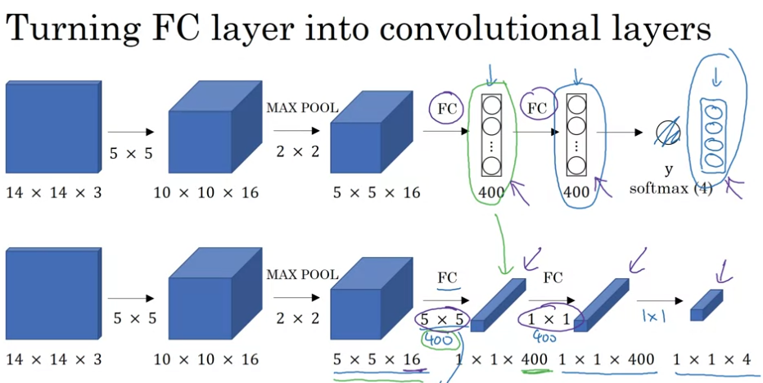

So, the convolutional implementation of sliding windows, what it does is to apply a series of convolutional layers and max pool layers so that you end up with an output image equivalent to applying a CNN four times in each window. This way, for an equivalent operation, you run your forward propagation only once, getting a net much more efficient computationally speaking.

Nota: I guess this way you end up with a series of parallel branches with different filter sizes equivalent to each sliding window sizes, performing all at once one forward computation for all the options of windows sizes.

#### Bounding box predictions: Yolo algorithm

What the Yolo algorithm does is performing a grid of the image and run an object localization model on each grid, outputting a bounding box and class probability for each grid and assigning the midpoint of the object to only one grid, avoiding that the same object gets located in more than one grid.

So, if you implement this algorithm convolutionaly, you end up training only one model which outputs a n_grids x 5 (bx, by, bh, bw and object/no object in image) x n_classes, which is super-efficient!

Note that the bboxes are coded relatively to each grid, as if the grid was the whole image. The problem with this is that the bbox can be bigger than just one grid cell, so it could be greater than 1:

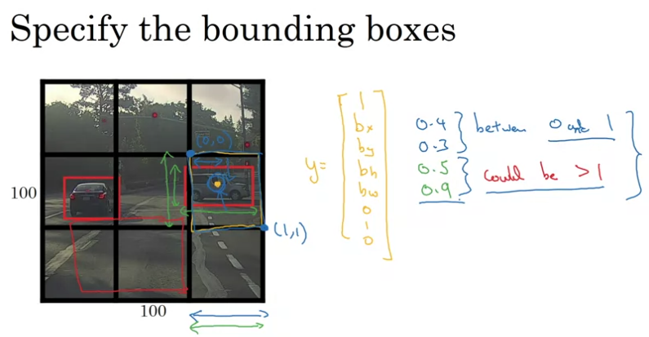

Nota: The problem with this algorithm as it is, is that if there are two objects in the same grid, only one is detected.

#### Intersection over union

It is a metric that evaluates how good your bbox location is.

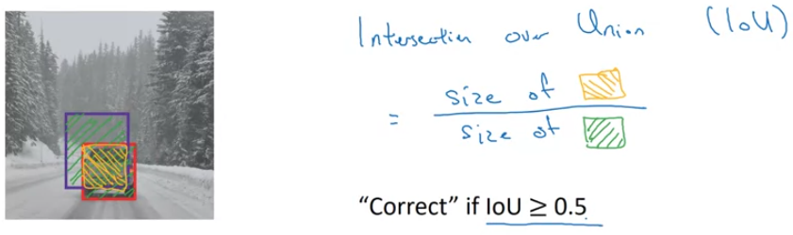

Even 0.5 is a very common threshold, it is just a convention. There is no strong reason for choosing this parameter, and you could choose a more stringent one if needed.

#### Non-max Suppression

It’s a way to be sure that each object is detected only once. If after running your object localization algorithm on all your grid cells you end up with several bboxes assigned to one same object, what non-max suppression does is to calculate the IoU of all these bboxes, look into the probabilities of each detection with great shared IoUs and only keep the one with the highest confidence.

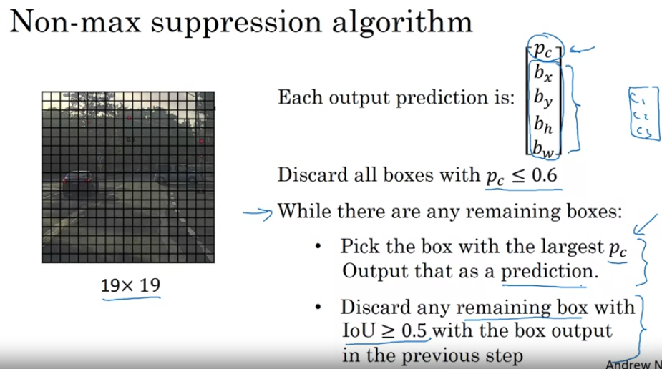

#### Anchor boxes

If you have two different objects sharing the same midpoint in the same cell, for the Yolo to be able to make multiple predictions, what you do is pre-define some anchor boxes for each object.

Then, each object is assigned to the grid cell that contains the object’s midpoint and the anchor box for the grid cell with highest IoU:

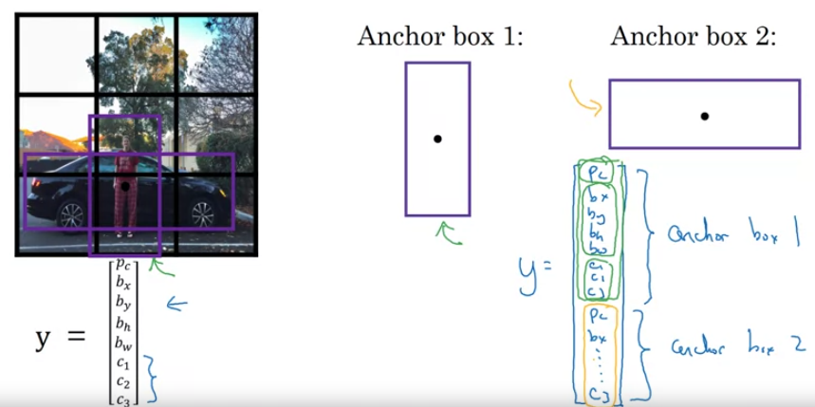

This way, you end up with an output vector y of the shape:

n_grids x n_anchor_boxes x (5 + n_classes)

Note: This algorithm can’t handle the cases where there are more objects per grid than anchor boxes, or where two objects in the same grid cell have very similar anchor boxes.

There are several ways of defining the number, shapes and sizes of the anchor boxes. Usually there are decided by hand or by machine learning algorithms like k-means.

##### How does Yolo deal with objects larger than a grid cell?

YOLO achieves this by predicting offsets and scales for each anchor box within a grid cell. As we have seen in the Bounding box predictions section, for the bboxes YOLO predicts four values: b**x**, b**y**, b**w**, and b**h**. The b**x** and b**y** values represent the center coordinates of the bounding box relative to the grid cell. These values are predicted as offsets from the top-left corner of the grid cell. The b**w** and b**h** values represent the width and height of the bounding box, also relative to the grid cell size.

To account for different object sizes, YOLO predicts scales for each anchor box. These scales are typically calculated as the square root of the width and height of the ground truth box divided by the corresponding width and height of the anchor box. By adjusting the scales, YOLO can accurately predict bounding boxes of various sizes.

So, these two steps are made for each anchor box. To obtain the final predicted bounding box coordinates, YOLO combines the predicted offsets and scales. The x and y offsets are added to the coordinates of the anchor box, which places the predicted box within the grid cell. The predicted widths and heights are multiplied by the scales and multiplied by the respective anchor box dimensions. This process enables YOLO to predict bounding boxes larger than the grid cell while still maintaining the relative positioning within the cell.

### Putting everything together: The Yolo algorithm

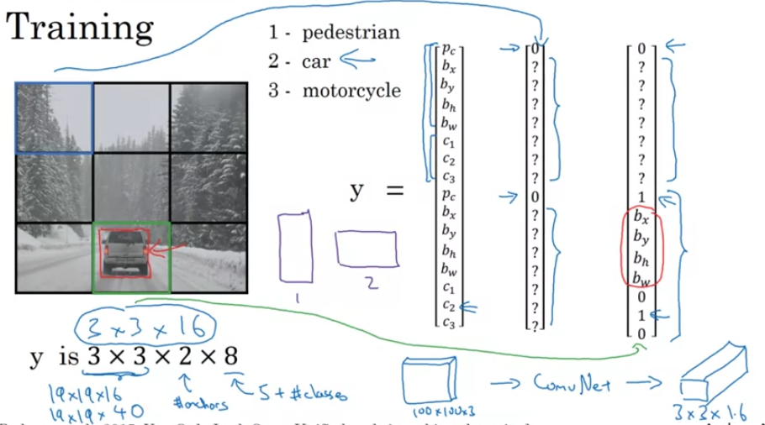

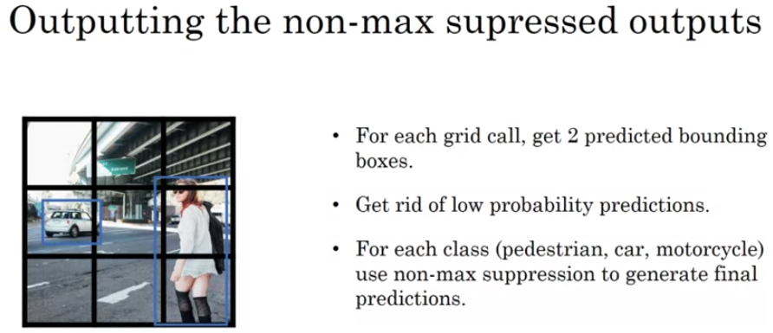

## Semantic segmentation with U-Net

### Region Proposals

Proposed in the R-CNN paper. And what that does is it tries to pick just a few regions that makes sense to run your detection. So rather than running your sliding windows on every single window, you instead select just a few windows, and run your continent crossfire on just a few windows.

The way that they perform the region proposals is through a segmentation algorithm in order to figure out what could be objects. Then, it proposes a limited number of regions of interest with their corresponding bboxes, and runs the detection algorithm only in those regions.

Evolution of R-CNN:

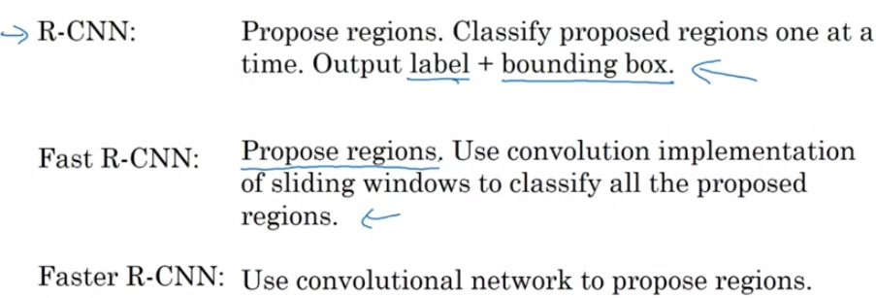

### Semantic segmentation

Semantic segmentation consists in classifying an image pixel by pixel, so you can know exactly which pixels belong to a certain object and which don’t.

It performs then per-pixel class labels, outputing a matrix of labels. For doing so, it follows a encoder-decoder architecture, bias transpose convolution:

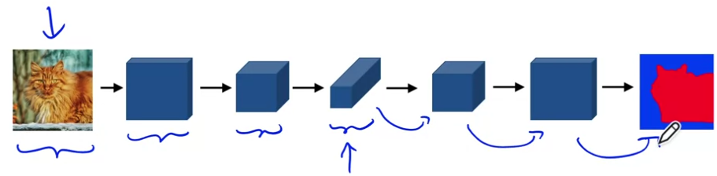

### Transpose convolution (deconvolution)

In transpose convolution, you take an input and what to obtain an output of bigger size. For doing so, instead of placing the filter on the input, you would instead place a filter on the output.

Then, you multiply all the elements in the filter by the first element of the input, and once the whole window has been multiplied and their values have been placed in the output, you slide it to the next position and multiply the whole filter by the second element of the input and so on.

Where two windows overlapp, the values are summed up:

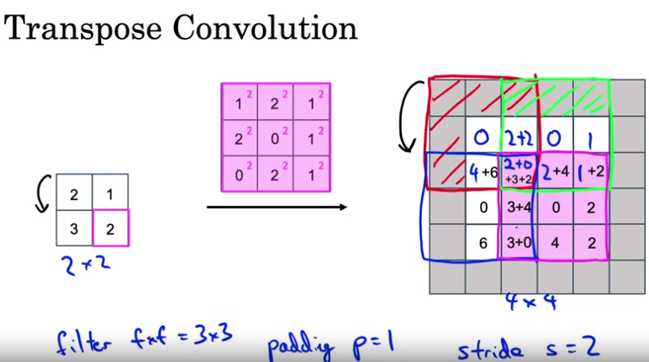

There are multiple possible ways to take small inputs and turn it into bigger outputs, but the transpose convolution is effective and when you learn all the parameters of the filter, this gave good results with the U-Net architecture.

### U-Net architecture intuition

The first part of the net is in charge of “compressing” the image, therefore losing a lot of spatial information but getting much deeper. This gives way too more complex features, but which are much less precise in terms of location.

The second part of the net takes the representation back to the original input size, and in order to keep the spatial information, the activations of the layers of the first part are added to the layers of the second part by skipped connections.

This way, it can benefit from both the lower resolution, but high level, spatial, contextual information, as well as the low level but more detailed information in order to make a decision as to whether a certain pixel is part of a class or not.

### U-Net architecture

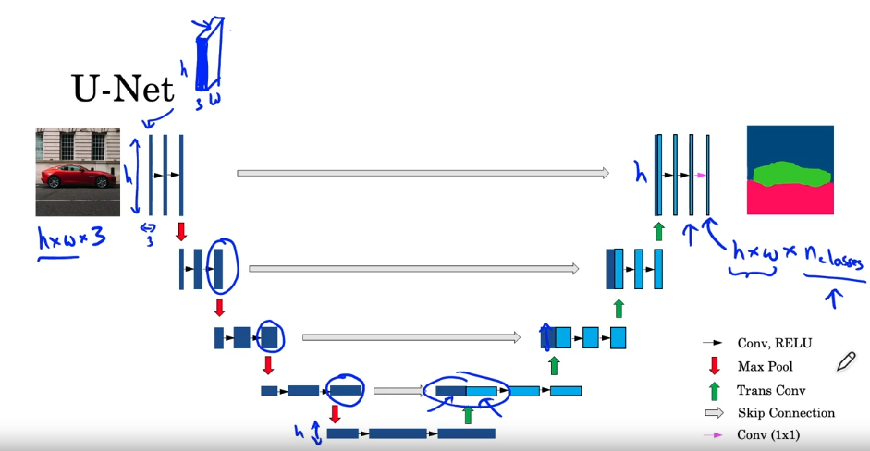

## Face recognition

### What is Face recognition?

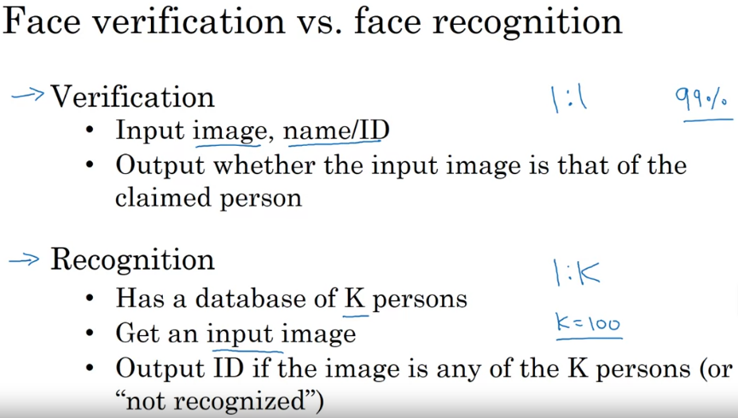

In the end, the difference lies in that face verification compares the input image with only one image in your database, whereas face recognition tries to obtain a match between an input image and K possible matches from a database.

### One shot learning

It’s the kind of problem where you only have one training example for class. It’s the typical case of the face recognition task.

The way to address this problem is by learning a similarity function, instead of training a classification net. Then, you have a function that takes as inputs two images and returns a degree of difference between images, which you can compare to a threshold to determine if it’s the same image or not:

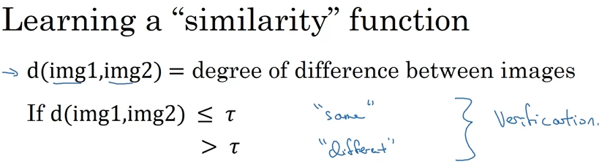

### Siamese Network

It consists in a CNN that instead of having a softmax ends up by outputting a vector that encodes the information of an image. Then, you can run the different images in this same net and compare this output vector, to see how much different they are:

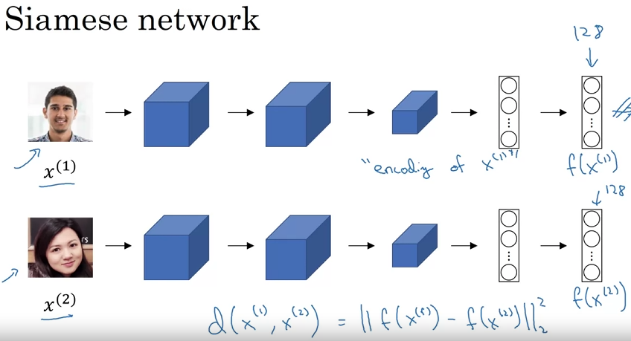

### Triplet loss

It’s the loss function that will led your model learn a function that maximizes the d value when the images are different and that minimizes it when the images are the same.

For doing this training, you use an anchor image and compare it to different images labelled as positive and negative images.

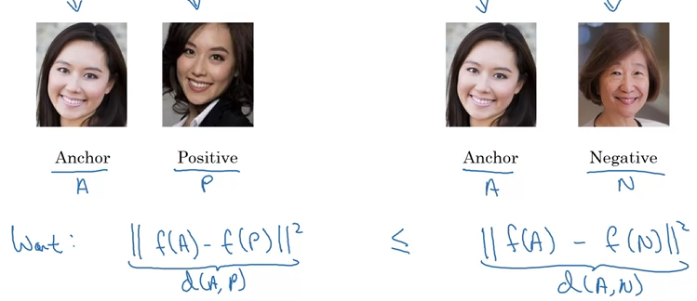

You could just minimize this equation:



But it can overfit in two different ways:

1. If it always outputs 0, then the equation is satisfied
2. If it always outpus the same d vector, the equation is always satisfied too.

In order to avoid these problems, they add a parameter to force the algorithm to really learn a f(x) that outputs a similar vector to f(A) when the images are positive matches and at the same time makes f(N) very different from f(A).

This parameter is known as the margin, and it’s a hyperparameter to tune:



And this is known as the triplet loss, which the CNN will try to minimize. It can be coded as:

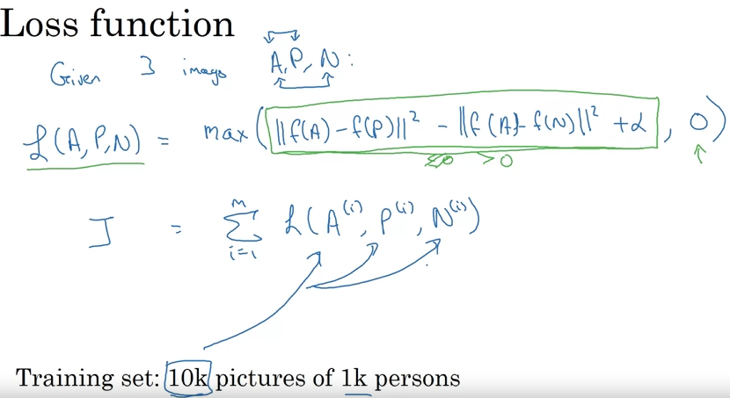

Where you will need pairs of positive and negative images to compare at the same time to each anchor. But there is a problem choosing this triplet of Anchor, Positive and Negative:

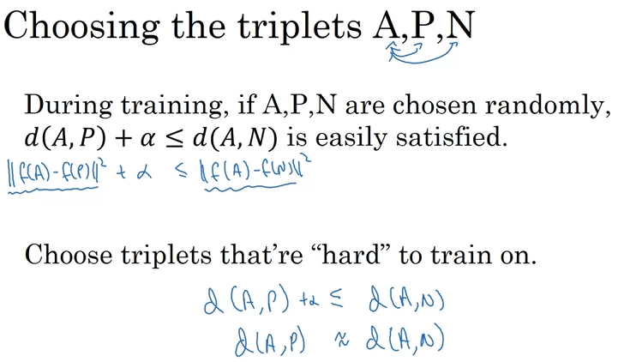

Nota: This is a domain where the models need huge amounts of data to be trained, so it is specially recommended to use previously trained weights which have are publicly available.

### Face verification and Binary Classification

Alternative to the triplet loss. What you do is you train your Siamese network by inputing two different images, one in each model, subtracting the embeddings obtained by each model and introducing this subtraction into a final unit with a sigmoid:

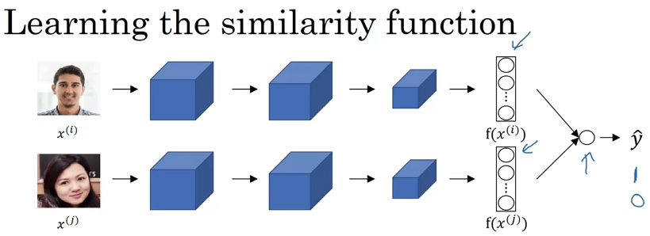

Now the loss function will have this shape:

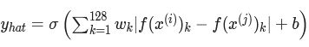

Where 128 could be any number of hidden units. There are other difference functions that could be implemented, like the chi squared.

When implemented in application, what you can do is precompute the features in one of the models so you don’t have to make the forward propagation each time you want to compare a new image:

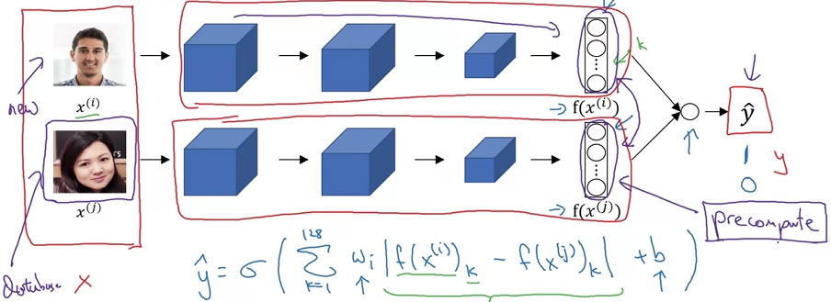

## Neural Style Transfer

### What is Neural Style Transfer?

It’s a model that takes a content image and a style image and then tries to generate a new image with the content and style of the respective images.

### Understanding CNN activations

You can go through each unit in a certain hidden layer and look at what are the image patches that maximize the unit’s activation, so you can see in what parts of the image your net is focusing.

By repeating this process through all of the layers in your model, you can see how as you go deeper into the layers, it focuses in larger parts of the images and in more complex objects:

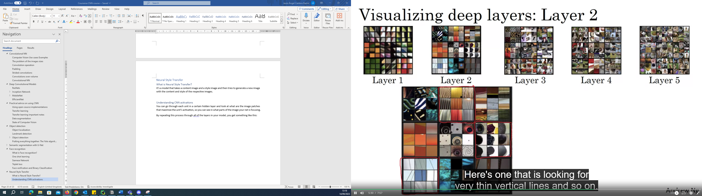



### Cost function for Neural Style transfer

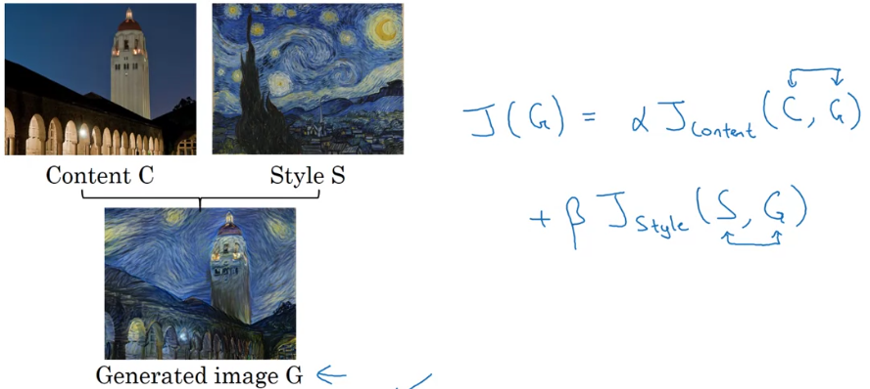

Where alfa and beta are two hyperparameters that led you weight the content and the style.

### Content cost function

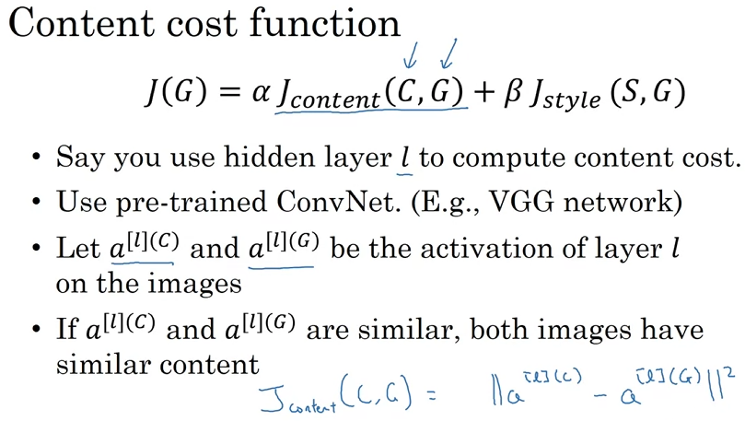

### Style cost function

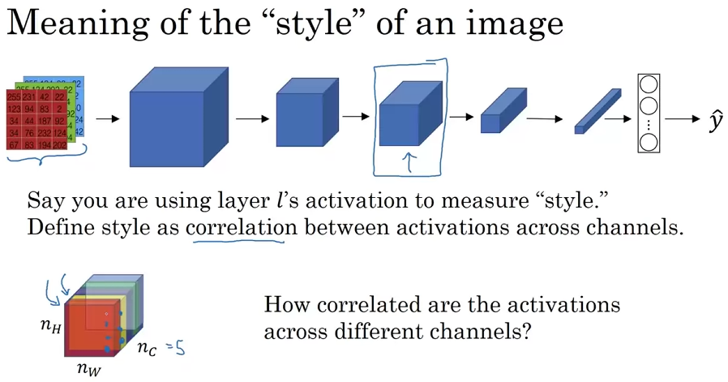

In order to measure style, you look into the correlation between the activations of points in the same positions across different channels. That is to say, when a certain feature appears in one channel, how often it coincides with the features in other channels.

This way, you can create a style matrix as follows:

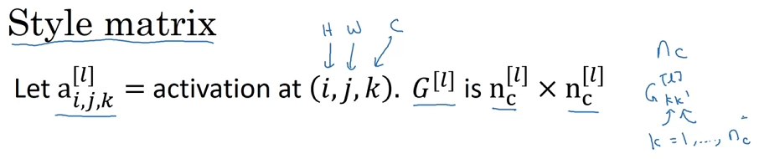

We calculate the style matrix as the unnormalized cross of the areas of the activations in each layer:

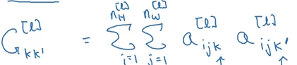

And we calculate the style matrix for both the style image and the generated image. This way, we end up defining the style cost function as the difference between these two matrices as:

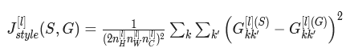

The results are better when you sum up the cost function of the different layers:

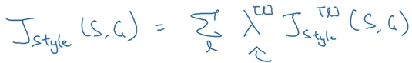

Where lambda is a parameter with a different value for different layers.

Note 1: The deeper layers capture higher-level concepts, and the features in the deeper layers are less localized in the image relative to each other. So if you want the generated image to softly follow the style image, try choosing larger weights for deeper layers and smaller weights for the first layers. In contrast, if you want the generated image to strongly follow the style image, try choosing smaller weights for deeper layers and larger weights for the first layers.

Note 2: There are not parameters to train in this CNN. The cost function in Neural style transfer serves to optimize the values of the output pixels, while the pretrained CNN remains untouched.

### Convolutions in 1D and 3D data

They actually both work the same way as in 2D convolution.

In 1D you just convolve your n element filter through your m element input, performing an element wise multiplication and summation and sliding the filter. This way, you end up with an output with a size following the same formula as in the Conv2D:

$$Output_size \frac{= input_size+2*padding – filter_size }{stride}+ 1$$

In 3D, you convolve your 3D input by a 3D volume filter just the same way as in 1D and 2D, sliding it through the whole volume.

# Sequence models

Are those which deal with sequence data: data in which the points in the dataset are reliant on the other points in the datase.

## Notation

For noting the element t of a sequence in a sample i of feature x, we use the following notation:

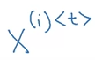

When dealing with sequences of words, you need to create a dictionary, where each possible word is indexed. In this example, the word harry would be coded by putting a 1 in the index 4075 and putting the resto to zeros:

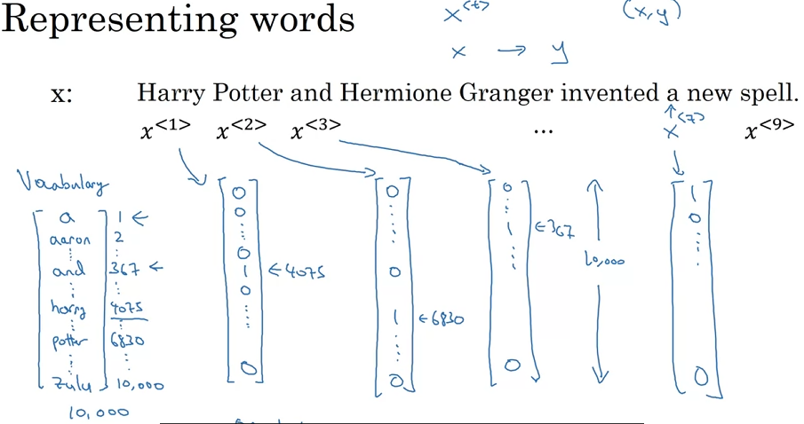

In commercial applications, dictionaries typical sizes are around 3000 and 50000 words.

Note: If you find a word that is no present in tour dictionary, what you do is to create a new token called unknown, and you fit all the words that are not in your dictionary in there.

## RNN

### Why not use a standard NN?

The need of a specific type of NN model for sequences comes from two main problems:

1. Input and output lengths can vary in different examples
2. As the CNN are better for learning spatial features, sequence models are better for learning sequence dependencies.

### What is a RNN?

A recurrent neural network is a kind of model that accumulates in a certain way the information from previous timesteps when computing the prediction for the actual time step:

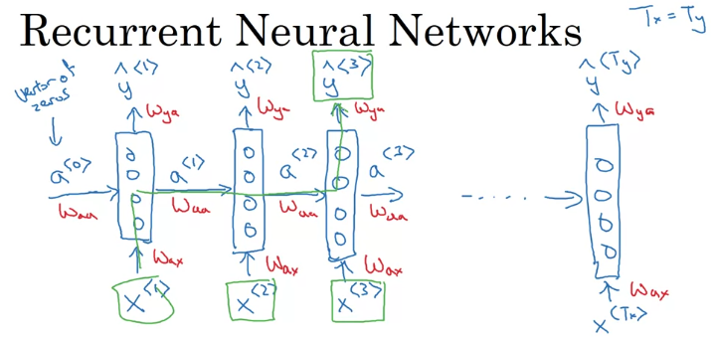

You also have a made-up activation at time 0, which is usually initialized with all zeros.

There are three sets of parameters that the model learns and uses for all the timesteps predictions, which are Wax, Waa and Wya. From these weights, the different output are obtained accrding to the following formula:

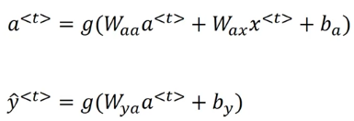

Where g is an activation function.

Note that the first subindex from the different parameters denotes the output while the second subindex denotes the element the weights are multiplied to.

To simplify the formula, Waa and Wax can be concatenated into Wa, which can be matmultiplied by the concatenation of at and xt.

### Backpropagation through time

The backpropagation can take the following loss function as starting point:



And the total loss for a specific sequence can be obtained as the sum of the losses for each timestep.

Then, as the forward propagation goes from step 1 to the final step, the backpropagation goes in reverse, starting by the final step until it gets to the first step.

### Different types of RNN

1. **Many-to many architecture:** For each step in the input, you get an output.
2. **Many-to-one:** From the input sequence, you only get one output, as for sequence classification.
3. **One-to-many:** From one single input, you generate a whole output sequence.
4. **Many-to-many with different lengths:** The input sequence and the output sequence have different lengths. They have an encoder-decoder architecture.

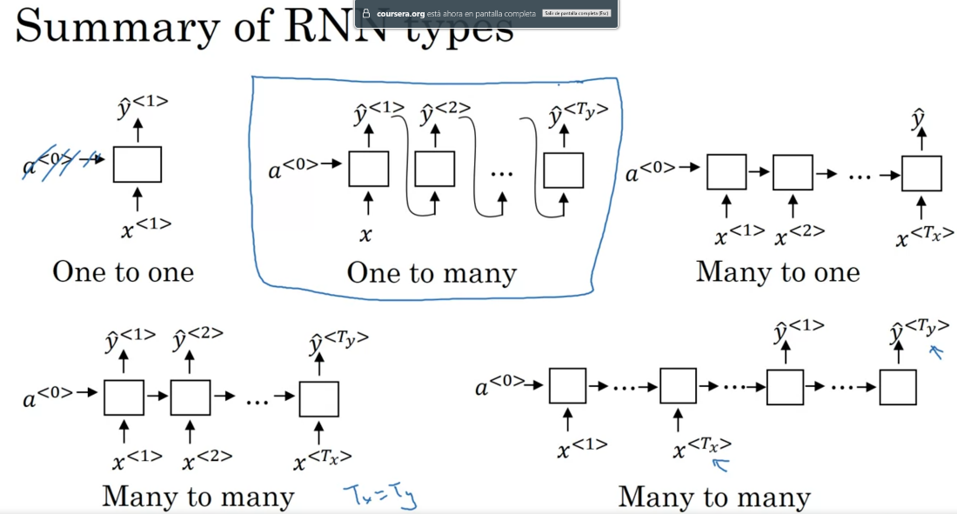

### Language model and sequence generation

A language model assigns a probability to each sentence and picks the one with the highest probability. That means that given any sentence, it gives the probability of that sentence depending on the context it has learned.

To train such a model in the training set you introduce a large “corpus” of sentences, which you tokenize and represent as one hot encoding vectors depending on the dictionary you have built. You usually also want to represent the end of a sentences, which you can do by adding an entry to your dictionary known as EOS (End Of Sentence).

Once you have your training set tokenized, to train the model what you do is start feeding the model with the first words of a sentence and making it predict the next word based on the words already existent in the sentence:

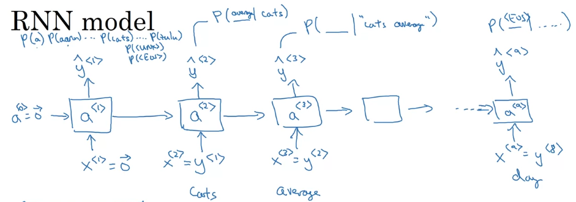

And the lost function for this model would be:

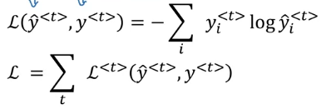

Where yhat at time step t is the conditional probability for each time step given the previous time steps.

### Sampling novel sequences

It consists in generating sample sequences with your trained model to have an idea of what it is that it has learned. So in order to do that, you start by inputting a 0 vector and generate a first probability prediction. Then you will randomly select a word, following the prediction’s distribution, and feed it back to the RNN, as a new input. Doing this for the following steps, you end up with an artificially generated sentence!

Note that the sentence will end once the EOS token is selected as prediction, or if you don’t have this token in your dictionary, you can decide a maximum sequence length.

As you can build a dictionary at word level, you can also create one at character level, so your predictions will also be sequences of characters.

The character level dictionaries have the advantage that you don’t have anything out of your dictionary, so theoretically it could produce any sequence of characters, which means any kind of word and sentence. The main disadvantages are that you end up with much longer sequences, which makes it more difficult for the model to retain the long range dependencies between the earlier and later parts of the sentence; and the computational cost.

### Vanishing gradients with RNNs

As the sequences are prolonged, the weights get forward and back propagated more times, so it is more difficult for steps early in the sequence to influence elements that appear much later. This is to say that the RNN models have many local influences.

Note: The same problem applies to exploding gradients, but they are easier to identify as they commonly led to NaNs, and to solve them you just need to apply gradient clipping.

## Gated Recurrent Units (GRUs)

We look into the RNN as a base for the GRU:

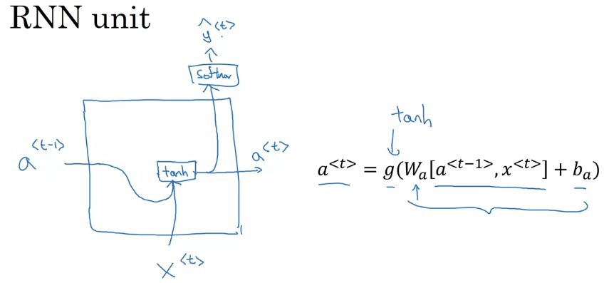

What the GRU does is to reconceptualise the activations as memory cells and add a gate which decides if the memory cell is updated or not:

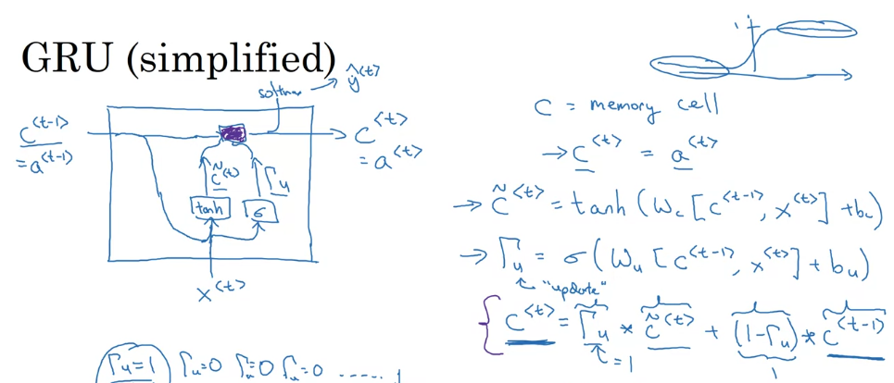

This way you can keep values known at the beginning of the sentence up to the when they are needed. Note that the multiplication is element wise, so the GRU can decide to update some parameters of the vector C and some not.

The complete version of the GRU has one more element:

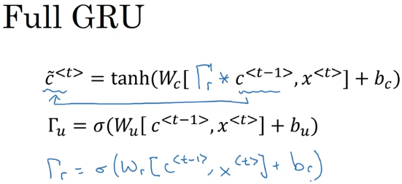

This gate Gamma r tells you how relevant is C^t minus 1 to computing the next candidate for C^t.

## Long-Short Term memory

The LSTM is an even slightly more powerful and more general version of the GRU.

The first difference it has with GRU is that it differentiates between the memory cell unit and the activation. Then, it has a parameter as the forget gate, a parameter as the keep gate and a third parameter as the output gate:

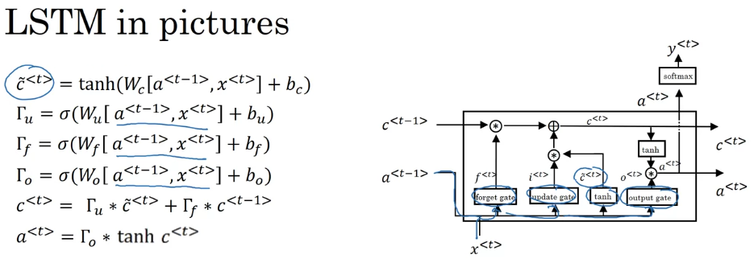As it can be seen in the picture, this way you have two different lines, one for the memory cell and the other one for the activation. IT can also be appreciated that the output still only depends directly of the activation. And you link different cells by these two branches in parallel, as shown in the following picture:

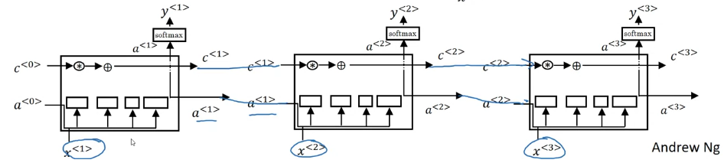

## GRU vs LSTM

GRUs are simpler, so computation runs a bit faster, and allow to grow bigger models. On the other hand, LSTM is more powerful and more flexible since there's three gates instead of two.

## Bidirectional RNN

This technique applies to all the basic RNNs, GRUs and LSTMs. It consists in feeding both the previous and the next timesteps into the model.

For doing so, you add cells that are connected in the inverse direction, computing the sequences in reverse order, and using the activations of both types of units for obtaining the predictions:

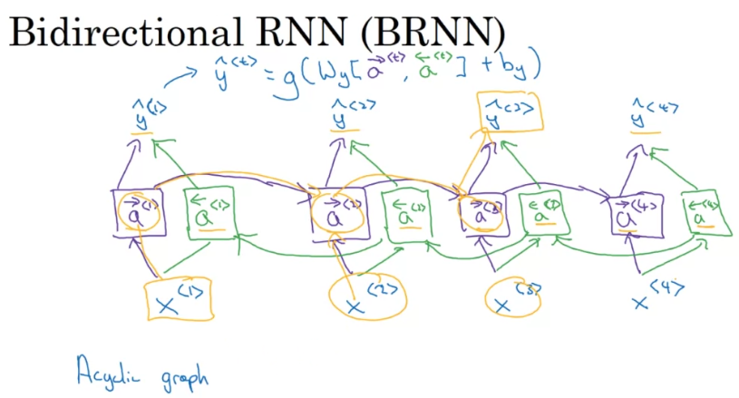

Note that before a prediction can be outputted, the forward pass needs to have been previously done in both directions through all of the sequence. Then, this network can be applied to problems where you get the whole sequence and then you need to compute an output for the whole sequence.

## Deep RNNs

When you stack RNN (same for GRU and LSTM), what you do is feed the output of each timestep into the next layer at he corresponding timestep, as shown in the following picture:

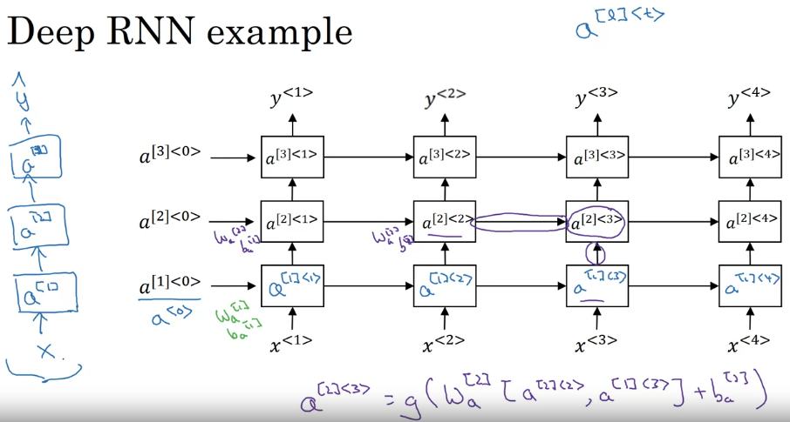

Note that the number of units corresponds to the dimensions of the weights.

Note: For RNNs, having just 3 layers is a lot, because of the temporal dimension these netwrks can get big enough with only a few layers.

## Natural Language Processing & Word Embeddings

### Word representations

With a dictionary as just one-hot representation of all the vocabulary, the problem is the model cannot learn the correlation between different words, and then it finds it difficult to generalize.

To solve this issue, you change your word representation to a featurized representation through word embedding. This way, in addition to indexing each word in your dictionary, you also associate a series of features to each one.

You can visualize your embeddings through the t-SNE algorithm due to Laurens van der Maaten and Geoff Hinton, which takes your n_features dimensional space and reduces it to a 2D representation, where you can see how the different words belong to different clusters with similar features.

For notation, $O_{idx}$ refers to the word in the idx index whereas $e_{idx}$ refers to the feature vector of the word in idx.

### Using Word Embeddings

Word embeddings are learned using databases with billions and hundred billions of words, so you can use these embeddings in your smaller applications. Here is the workflow:

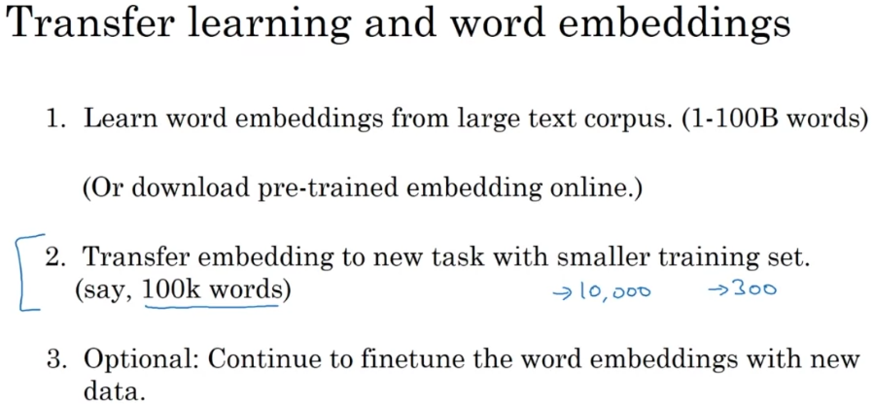

You usually only try to finetune if you have a big data base in your application.

### Properties of Word Embeddings

**Analogies:** Word embeddings allow to find analogies by comparing the subtraction of feature vectors for different words, determining an analogy by the similarity between these subtraction vectors. For example:

$$If man→woman then king→?$$

$$e_{man} - e_{woman} ≈ king -e _{?}$$

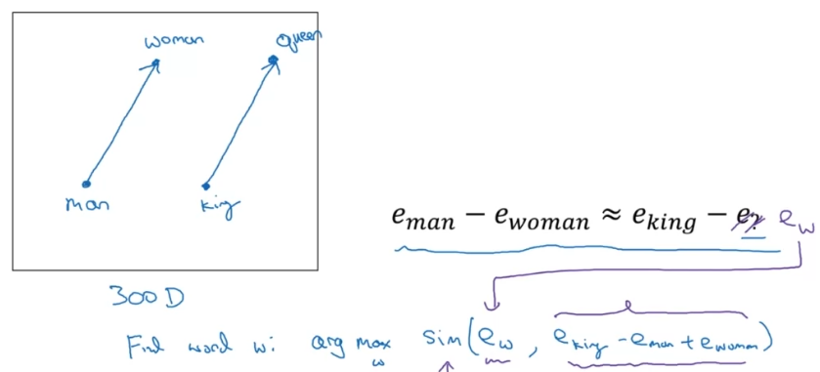

Note: After t-SAE transformation, this kind of relationships are lost as the non-linearity of the operation breaks them.

The most used similarity function is the cosine similarity function, although Euclidean distance could also be used:

Cosine similarity:

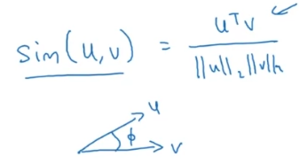

Euclidean distance:

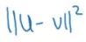

### Embedding matrix

When you implement an algorithm to learn a word embedding, what you end up learning is an embedding matrix. This matrix has dimensions n_features x n_words, so you get the feature vector for each word by multiplying this matrix by the one hot vector representing each word:

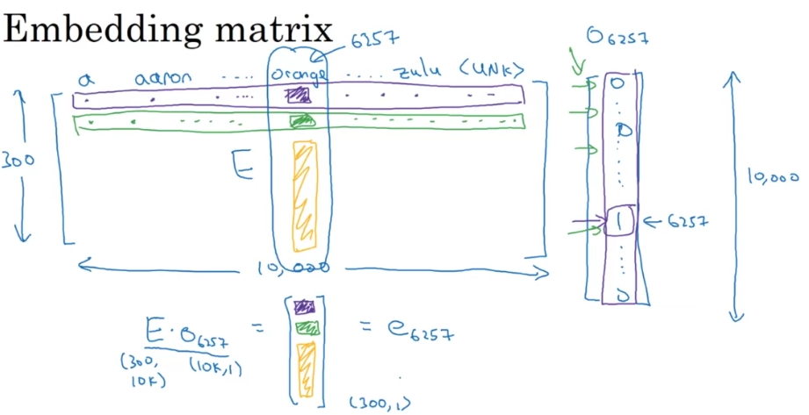

### Learning Word Embeddings

#### Neural language model

It consists in feeding a simple NN with the product of an embedding matrix E with the one-hot vector encoding each word in our dictionary, obtaining an embedding vector for each word. Then, these vectors are fed into a dense layer followed by a softmax, which tries to predict the next word from the given words.

For doing so, one hyperparameter is the history window, which consists in always taking the same number of words for predicting the next word. This history window is also known as the context, and there are different types of contexts you can choose. For example, you can change the window size or get words from both before and after the target word.

On the other hand, the parameters that are learned are the embedding matrix E, as well as the network parameters.

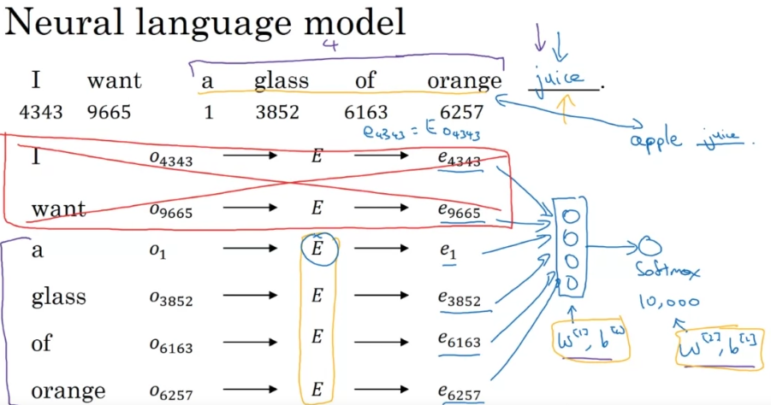

#### Word2Vec

##### Skip-grams

It consists in setting up a supervised learning problem where given the context word, you're asked to predict a randomly chosen target which is another word nearby the context word.

The workflow is the same, and you end up with a softmax that evaluates the probability of a target word given the context. This is done by comparing with all the other possible context embeddings, learning a parameter associated with the output, known as $θ_{t}$.

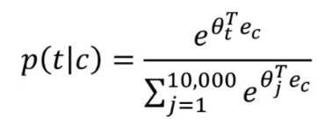

The problem of this algorithm is the computational cost, which can be alleviated with the implementation of a hierarchical softmax. It spares calculations by establishing decision trees of binary classifications:

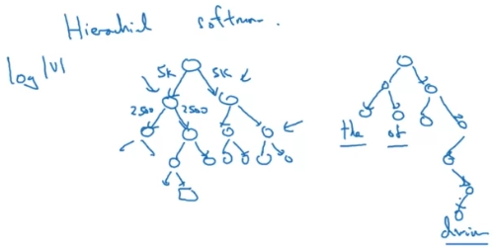

In practice, this hierarchical tree isn’t symmetric, but the most common words can be found earlier in the tree.

Note too that when sampling the context words, it is not recommended to use a uniform distribution, as some common words will appear more often, and your embedding matrix can end up being very biased.

##### CBow

It is known as the continuous backwards model, which takes the surrounding contexts from middle word, and uses the surrounding words to try to predict the middle word.

##### Negative Sampling

It is an approach that allows the Skip-Gram model to learn in a much more efficient way.

It works by first choosing a context word and a target word, and label them as 1. Then, you take k random examples from the dictionary and label them as 0. This way, for each positive example, you will have k negative examples.

With this dataset, you take the context and the other words, and try to make the model predict if the word is the target or not, i.e., learn to make the difference between both distributions:

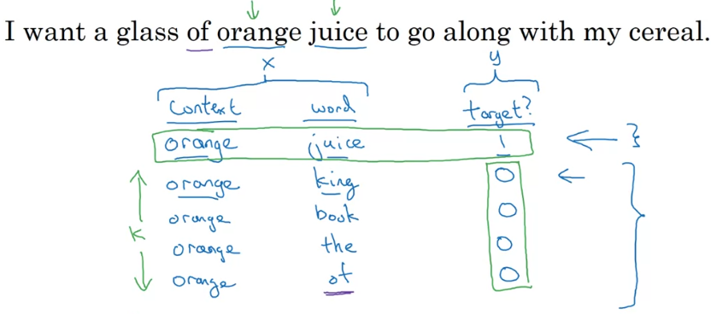

Note: It's okay if your randomly chosen word is in the sentence too.

The hyperparameter k is recommended to be between 5 to 20 for smaller datasets, and from 2 to 5 for bigger ones.

So for training the model using this approach, you feed the embedding vector of the context word and establish a n_words binary classification network, with n_words being of the size of your dictionary. But instead of taking all n_words neurons in each iteration, you take only your positive word and the other k words:

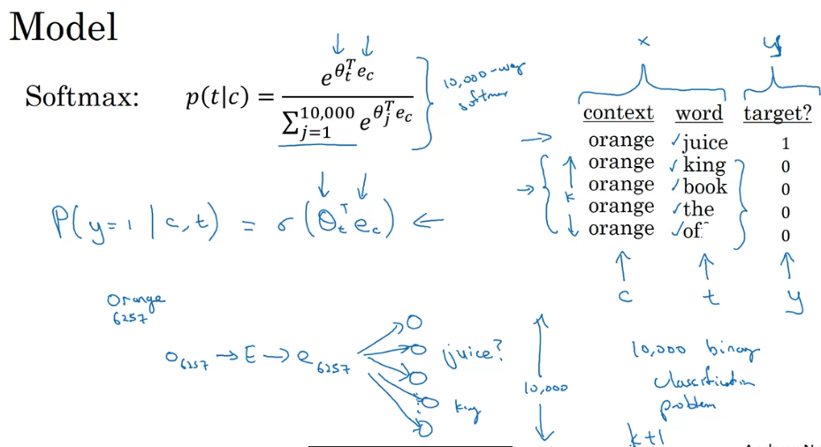

For choosing the negative samples, the authors developed the following heuristic empirically:

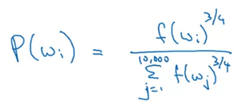

#### GloVe Word Vectors (global vectors for word representation)

It first defines $X_{ij}$ as the number of times a word j appears in the context of I, which is a way of measuring how much related are two words. So, for each pair of words i, j (context and target) what the model will try to minimize is the following formula:



Where $f\left(X_{ij}\right)$ is the weighting term, and is equal to zero if Xij is equals to zero.

For each word, you can obtain the embedding vector in the following way, knowing that j and ej are symmetric:

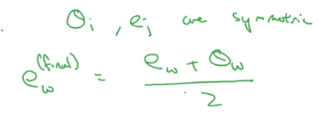

Note: You cannot guarantee that the individual components of the embeddings are interpretable, as they can be linear combinations of simpler features. However, things like analogies are kept, precisely because they are linear combinations.

### Applications using Word Embeddings

#### Sentiment classification

From a piece of text, you want to get a label. For training such a model, you extract as usual the embedding vector of each word and you can just sum them or average them. Then, you can just use a softmax for getting your labels:

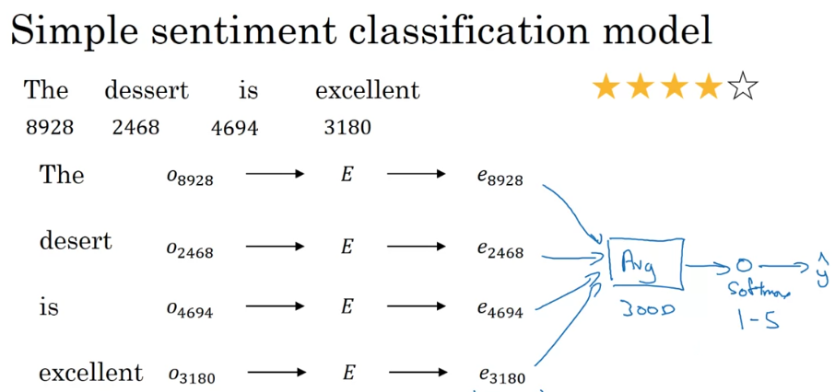

One of the problems with this algorithm is it ignores word order, so it can be biased if a positive word appears several times but like in a sarcastic or critical way. To solve this problem, you can apply any kind of RNN model:

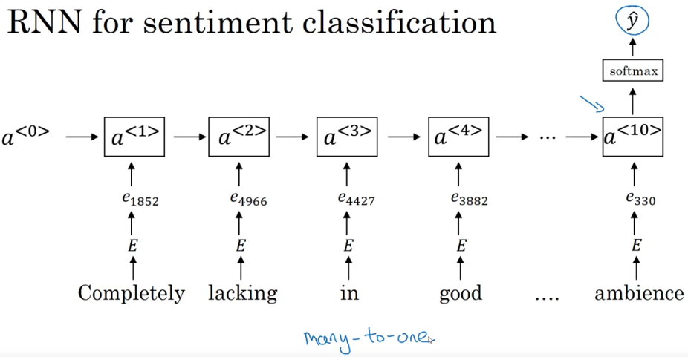

Another cool thing about word embeddings is that if you train a model but in your training set a certain word doesn’t appear, as long as it’s present in your word embeddings, it can still make a generalize to the test set.

#### Debiasing Word Embeddings

Word embeddings can reflect the gender, ethnicity, age, sexual orientation, and other biases of the text used to train the model. As learning algorithms can end up making very big decisions, it is important to eliminate or at least reduce these biases.

The workflow of bias adressing goes as follows:

1. **Identify the bias direction.** For the case of gender, what we can do is take the embedding vector for he and subtract the embedding vector for she, because that differs by gender. And take emale, subtract efemale, and take a few of these and average them (in the original paper, they apply a feature reduction algorithm).

This will allow you to figure out in this case that what looks like this direction is the gender direction, or the bias direction. So this direction will be low dimensional if there is a bias, or high dimensional otherwise.

1. **For every word that is not definitional, project to get rid of bias.** So for words that are not definitional, like doctor and babysitter, just project them onto the non-biased direction, eliminate their component in the bias direction or at least reduce it.
2. **Equalize pairs of definitional words.** This means making them equally distant to words which should not be biased. For example, make grandmother and grandfather equally distant to babysitter.

## Sequence models & Attention Mechanism

### Basic Models

#### Sequence to sequence model

You start by an encoder network, which outputs a vector that represents the input sequence, and after that you build a decoder network that takes this representation as input and returns the output sequence, one word at a time. For a translation example:

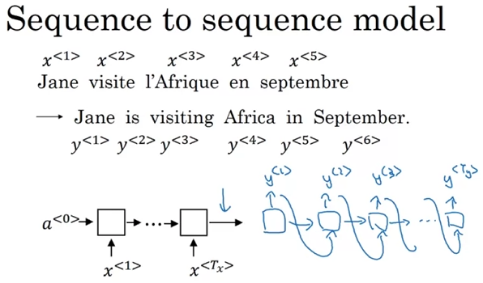

#### Image captioning

You train a CNN to get a series of features from the image, and take it as an encoder. Then you can take this model and feed the features to a RNN model:

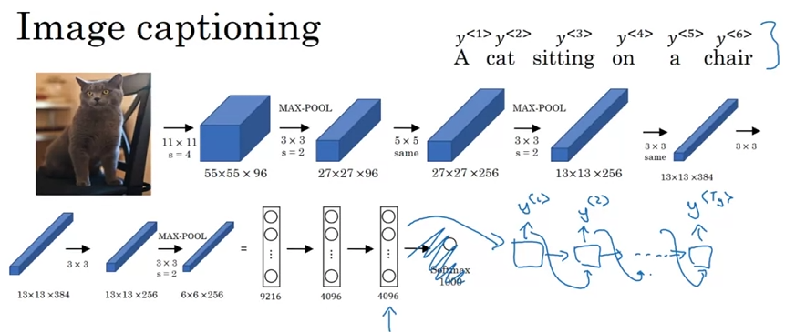

### Picking the most likely sentence for machine translation

Machine translation can be understood as a conditional model, where you want to know the probability of a translated sentence from the input sentence. Note that the decoder part in the machine translation model is similar to the model in the language model.

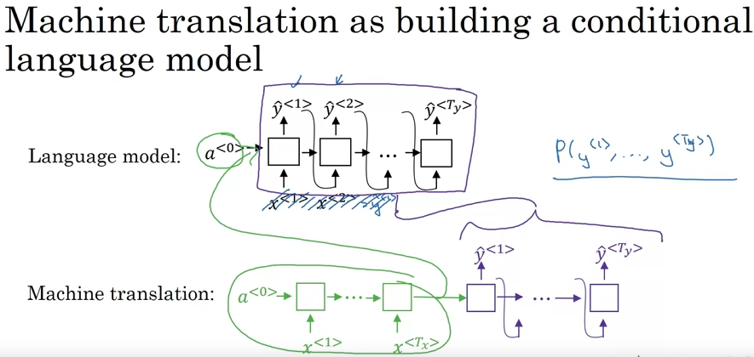

The main difference is that now you don’t want to sample a random sentence from the target distribution, but you look for the sentence that has the highest probability to match your input sentence.

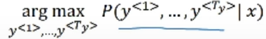

One common sense approach but that actually doesn’t work is the greedy search, where you start by trying to predict the best first word, and then given that word you try to predict the second word as the best second word and so on.

The problem with this is that it will be very biased to the most common words in your dictionary.

### Beam Search

Whereas greedy search will pick only the one most likely words and move on, Beam Search instead can consider multiple alternatives. This is controlled by the parameter B, known as beam width, which says how many words it is going to take into consideration as outputs. Then, for each option considered, it will input it in the next cell and again consider the B next most probable combinations knowing the previous output.

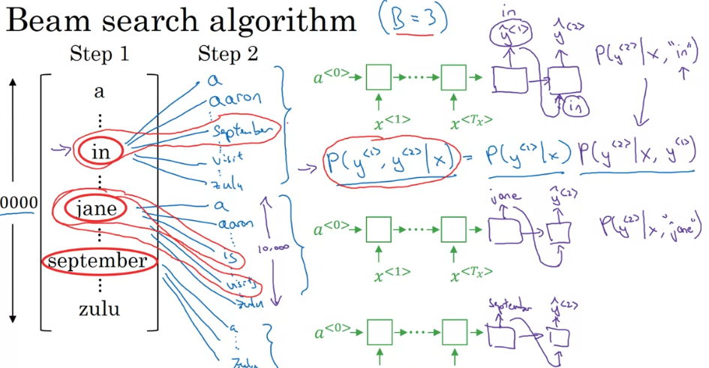

Notice that the algorithm will discard options as they fall appart from the rest.

Also, note that the network is copied B times.

#### Improvements to Beam Search

**Length normalization**

Note that what the Beam search algorithm does is to look for the maximum probability of each of the BN combinations. This can be expressed as follows:

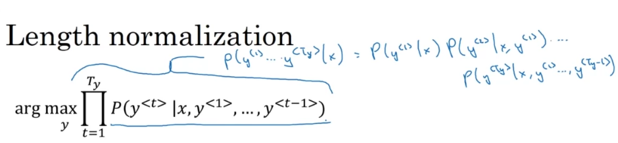

The thing is that the longer the sequence is, the smaller this number becomes, as all probabilities are always less than one. For avoiding a vanishing of the probabilities and increase the stability, we can apply log, which is a monotonically increasing function:

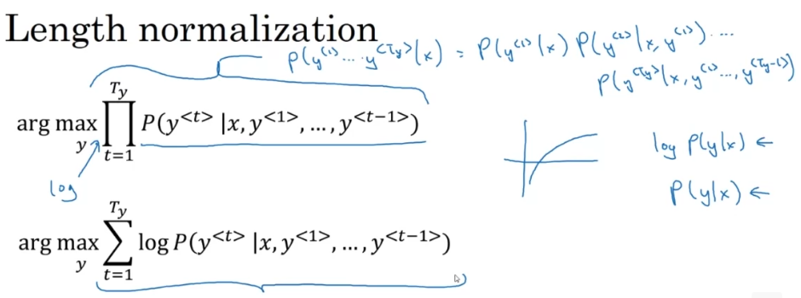

The problem with these two functions is that both penalize the longer sentences, so the algorithm will be biased towards shorter sentences. One because multiplications get too small, the other because the log becomes negative. To fix this, what can be done is to normalize over the length of the sentence:

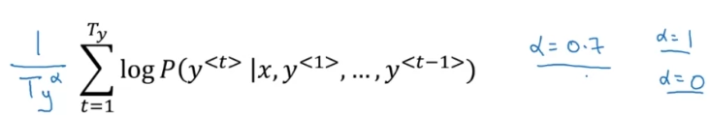

**How to choose the beam width**

The bigger the B, the better the result, but the algorithm takes more time. In production, the most usual is to fix B to be 10., but depending on the application or the domain, it can even get to 1000.

Note: Beam Search might not find the exact maximum, as it may refuse options that are worse in the short term but could be better in the long term.

#### Error analysis in Beam Search

Since the Beam algorithm can fail at founding the real maximum combination, error analysis can help you see if you should be spending more resources in improving your Beam algorithm or if it is better to focus on your RNN model.

So for doing this, you pass a translation that you know is good through the decoder and calculate the probability. Then you compare it with your algorithm predictions, and depending on which value is greater, you will be able to ascribe the problem to the RNN or to the Beam.

The logic is explained as follows:

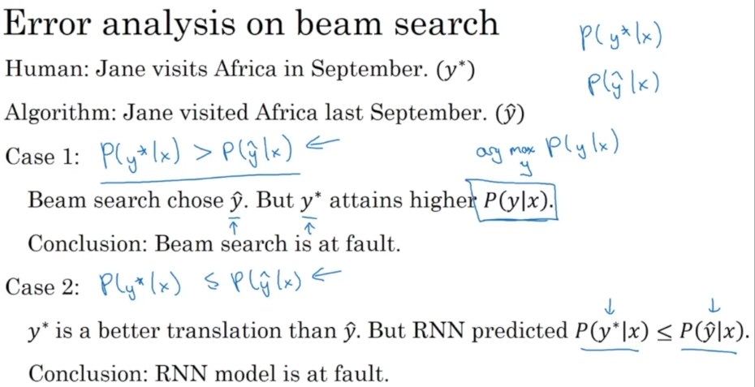

After running this process many times, you can count how many times one of the part has failed. So you can determine to work in the part that has failed more.

### Bleu Score

It is a method to measure how good the machine translation output is. And for doing so, in the dev and test set, it checks how many of the generated words appear in the label/refence sentence.

For doing so, it uses the bigrams, which are obtained by a sliding window of step 1 word and size 2 words. This way, you calculate the precision as the number of times each bigram in the output appears in any of the references, divided by the number of times each bigram is present in the output:

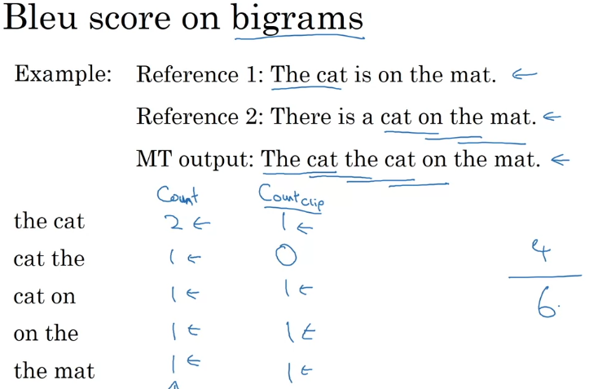

This notion can be extended to grams of size n:

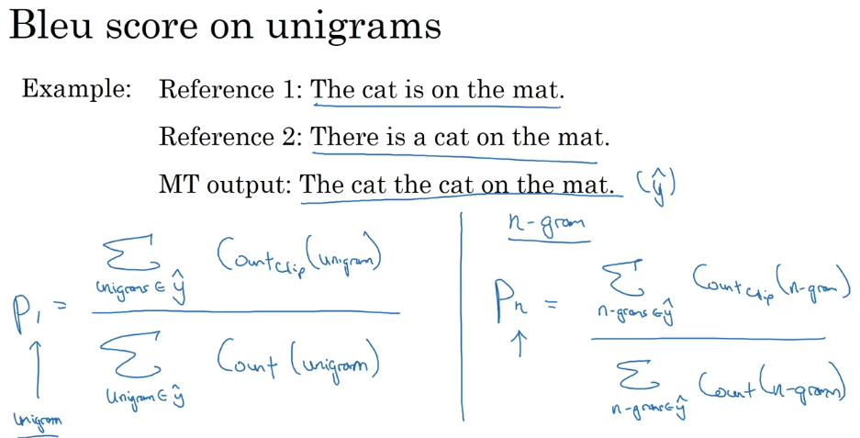

Finally, this sum is put as the exponent of e and multiplied by a BP factor, which is a brevity penalty:

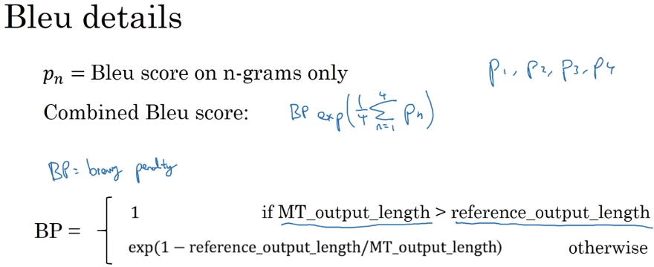

### Attention Model

#### Intuition

It is a modification to the encoder-decoder architecture. It helps handle better very long sequences, by focusing only in one part of the sequence at a time, instead of trying to compute the whole sequence at once.

For doing so, the attention model generates a set of attention weights alpha, which determine how much attention you should be paying to each element in the sequence to predict each output. This way, by adding up the multiplication of each alpha with the corresponding input step, the model generates what is known as context. And for the next steps, you also add the previous outputs info to the net.

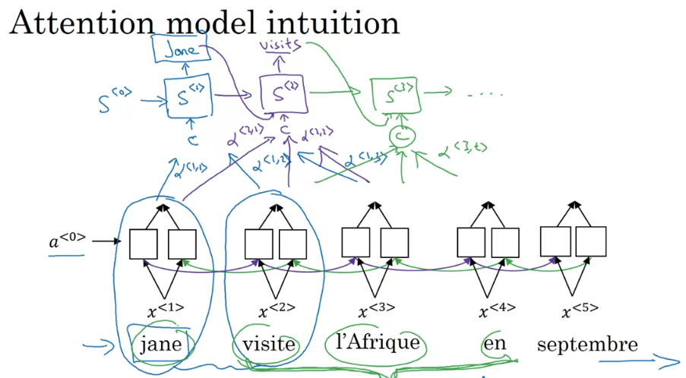

#### How the attention weights are computed

You use a softmax priorization to all alphas, so you make sure the sum is equals to 1. Each alpha looks like this:

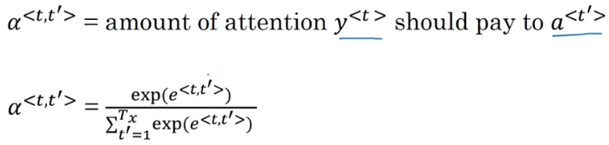

And to learn the terms e, you create a small NN network, which can learn how to represent e<t, t’> from each s<t-1> and a<t’>.

### Speech Recognition

It is a sequence-to-sequence model. You usually preprocess audios and convert them into spectrograms, which are 2D plots where the x axis corresponds to the time and the y axis corresponds to the power spectral density of the signal for different frequencies.

So one method consists in inputting one frame of audio at a time and feed it as one step of the sequence into an attention model which will try to output the corresponding element of the transcript for that audio frame.

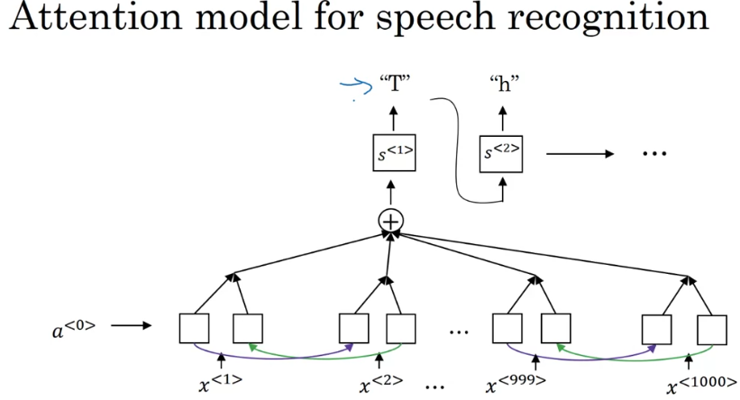

Another option is the Connectionist Temporal classification (CTC). The problem with speech recognition is that we have an output and an input which can have very different lengths. So what this does is predict for each audio step the corresponding transcript and allow it to repeat the same character. However, the model also learns to predict blanks and spaces, so you can reduce the output length by collapsing the predictions between blanks:

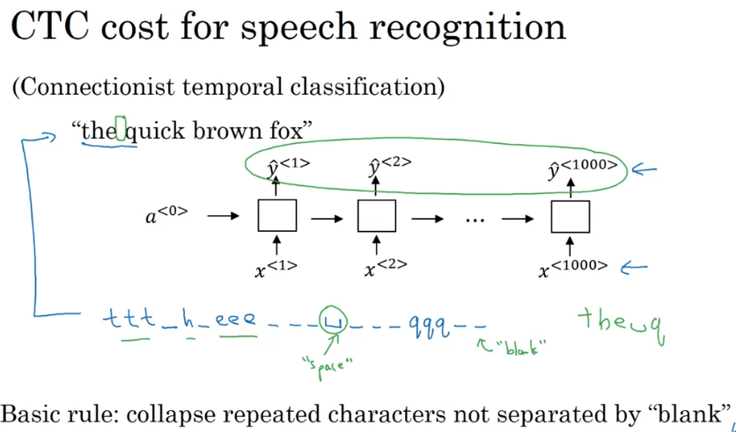

### Trigger Word detection (like Echo, Siri, Cortana, etc.)

There is not still a dominating paradigm in this application. What you can do is convert the audio to a spectrogram and set the labels to 1 for the steps that follow moment when the trigger word is pronounced. One problem of this application is that it consists in an anomaly detector, so you could end with quite an unbalanced training set. For solving this you can extend the number of steps with label 1 after the trigger word, or also eliminate some of the negative examples.

## Transformers

### Transformer Network intuition

State of the art in sequence models. In the previous sequence models, you need to compute one step at a time.

In opposition to these networks, the Transformer can perform the steps in parallel, computing all the sequence at the same time.

They combine the concepts of attention and CNN.

The attention network is based on two ideas:

1. **Self-attention:** It computes the representations of each word in the sequence. They are obtained in an attention-based way, and for all the words in your sentence in parallel.
2. **Multi-head attention**: It basically consists in looping through the obtained representations, so you end up with different representations of all the words in the sentence in parallel.

### Self-attention

You compute an attention-based representation for each word, using as inputs the Query, the Key and the Value.

The softmax equations used to calculate the attention weights, in comparison with the one for RNN, goes as follows:

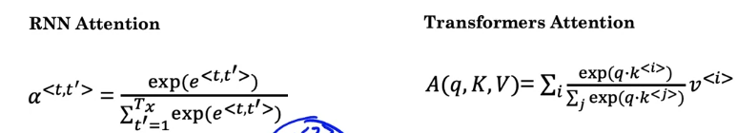

The Query, the Key and the Value are obtained from the word embeddings by multiplication of WQ, WK and WV respectively. These matrix are parameters of the learning algorithm:

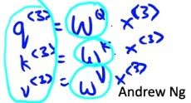

The concept of making Queries to obtain pairs of Key-Value come from the databases.

1. **Query:** It can be understood as a question to each word. It is used with an inner/dot product to the Key of each word to tell us how good of an answer is that word to the question. The goal of this operation is to pull up the most information that's needed to help us compute the most useful representation for each word.
2. **Key:** Qualities of words given a Q**.** It can be seen as the category of the word. So multiplying each query by each key, we get the higher results for the keys that best respond to each query.
3. **Value:** Specific representations of the words given a Q.

The key advantage of the self-attention representation is that it isn’t some fixed word embedding. Instead, it lets the model learn more richer and useful representation between the words in a sentence. *Me recuerda un poco al método que usaba el akinator para adivinar en que estabas pensando.*

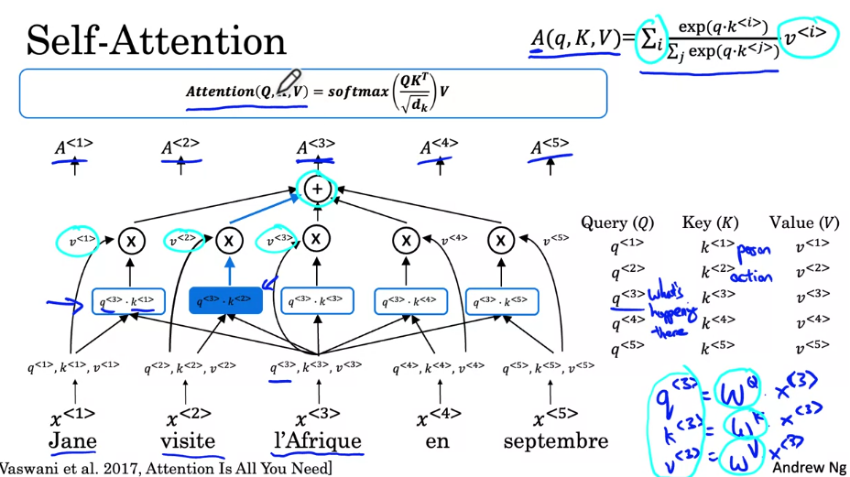

**Recap:** Associated with each of the words in a sentence you end up with a query, a key, and a value.

The query lets you ask a question about that word, such as what's happening in Africa.

The key looks at all of the other words, and by the similarity to the query, helps you figure out which words gives the most relevant answer to that question.

In this case, visite is what's happening in Africa, someone's visiting Africa.

Then finally, the value allows the representation to plug in how visite should be represented within A^3, within the representation of Africa.

### Multi-head attention

Knowing that a sequence is called a head, it’s easy to see that a multi-head attention model, what it does is it repeats the self-attention process several times (usually represented in literature as h). But, each time, it will learn a different set of matrices WQ, WK and WV. This way it can learn a new set of representations, with new questions and new relations between words. Finally, the different representations learned by each head are concatenated, and multiplied by a last matrix W.

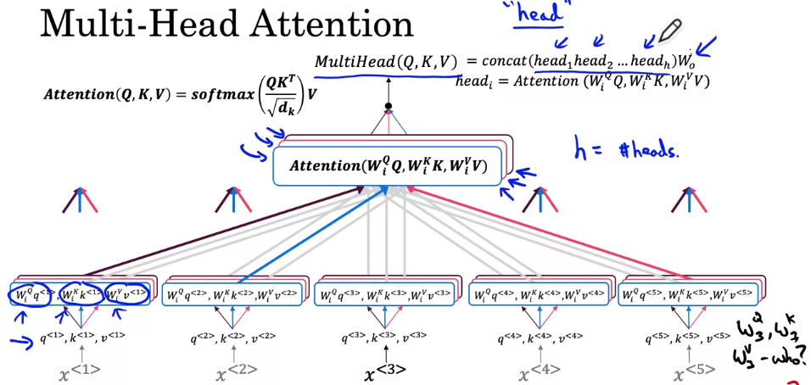

**Note**: The calculations for each head are done in parallel, which helps save a lot of computation time.

**Note 2:** In the previous section you learned that you calculate *q*, *k* and *v*vby multiplying *x* with matrices *W*. In case of the multi-head attention, you don't need to do this, as you already have the matrices *Wi* in each head, and you would effectively do the calculation twice if you did the multiplication with x too. In the simplest case of multi-headed self-attention you would actually use *q=k=v=x*. The reason we anyway show *q*q, *k*k and *v*v here as different values is that in one part of the transformer (where you calculate the attention between the input and output) the *q*, *k* and *v* are not all the same, as they carry different information as you will learn in the next video.

### Transformer Network

It starts with the decoder part, at the beginning of which we have a multi-head attention. This module has as inputs the values Q, K and V, computed from the embeddings and the weight matrices W:

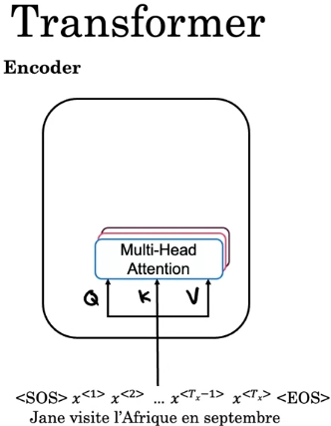

The features obtained from the multi-head attention are fed to a feed forward neural network. This encoder blocks is repeated n times, and the value of n is typically 6:

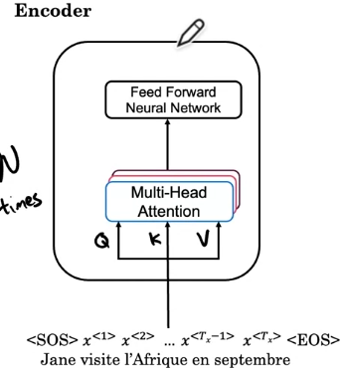

Then there is the decoder part. It starts with the first word of the sentence as input, which is processed through another multihead attention block. The output of this block is a new Q, and it is fed to a new multihead attention block, together with the K and V values obtained as output from the encoder. The output of this block is fed into a feed forward NN, and the whole decoder block is repeated n times, with n usually being 6. Finally, a predicted word is produced:

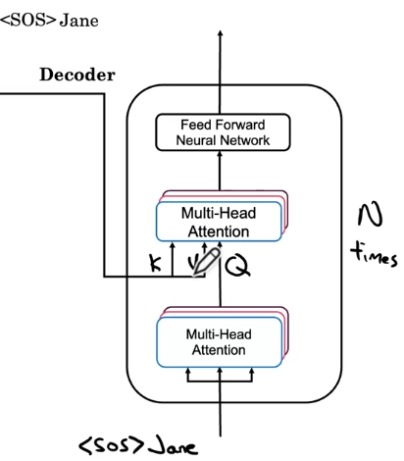

The predicted word is then fed back into the decoder and the whole process starts again.

The whole structure of the model would then be as follows:

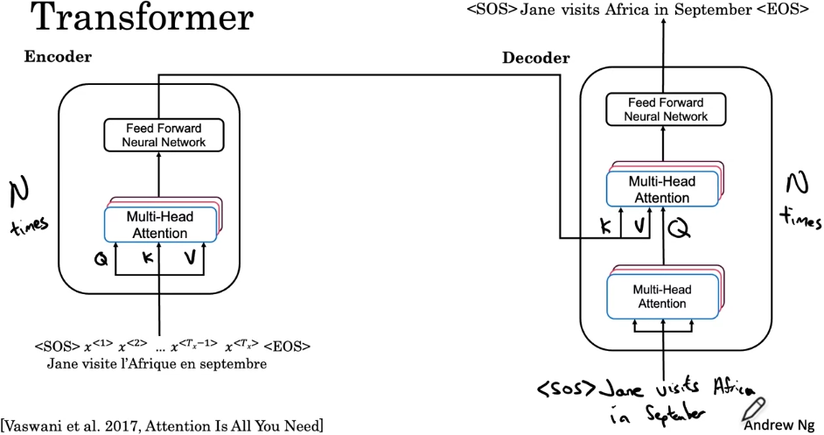

To this structure, the positional encoding of a word in the sentence is added, as it is a critical feature. It is added using a cosinus and sinus functions, creating a position vector, as shown in the next image:

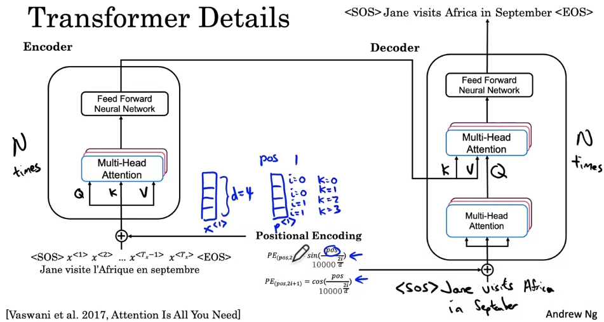

This positional encoding is directly added to the x vector which is fed into the transformer network, both to the encoder and the decoder. Note that if you just hard code the positions in, say by adding a matrix of 1's or whole numbers to the word embedding, the semantic meaning is distorted. Conversely, the values of the sine and cosine equations are small enough (between -1 and 1) that when you add the positional encoding to a word embedding, the word embedding is not significantly distorted, and is instead enriched with positional information. You can also weight each term to give more importance to the word embedding or to the position.

The output of the encoding block contains contextual semantic embedding and positional encoding information, and has the same length as the maximum length of sequence your model can take.

Other extras to this network are the implementation of residual connections and a layer add norm that is very similar to the batch norm layer.

Finally, the output of the decoder is fed into a linear layer, followed by a softmax layer to produce the final output:

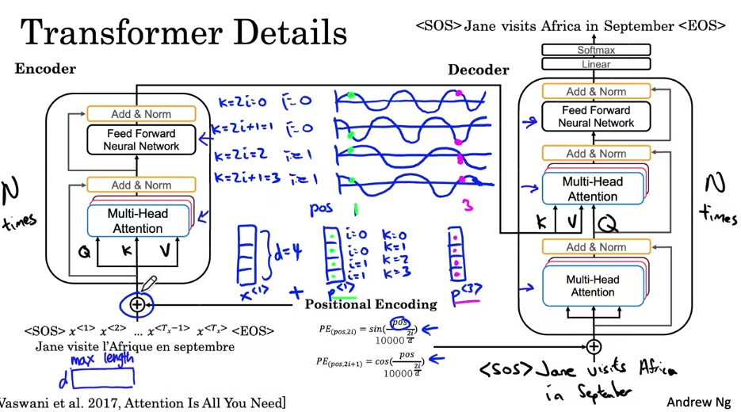

Finally, during training, the first muti-head attention module is replaced by a masked multi-head attention module. All that mask multi -head attention does is it repeatedly pretends that the network had perfectly translated, say the first few words and hides the remaining words to see if given a perfect first part of the translation, the new network can predict the next word in the sequence accurately.

### Named entity recognition

Named-entity recognition (NER) detects and classifies named-entities, and can help process resumes, customer reviews, browsing histories, etc.

You must preprocess text data with the corresponding tokenizer to the pretrained model before feeding your input into your Transformer model. This tokenizers split words into subwords. Before processing, it is important that you align the start and end indices with the tokens associated with the target word.

### Question answering

For answering a question, the goal of extractive QA is to identify the portion of the text that contains the answer to a question.

Nota: Comparison between PyTorch and TensorFlow:

PyTorch is a relatively light and easy to implement framework that can make rapid prototyping easier, while TensorFlow has advantages in scaling and is more widely used in production